**ECGR 4161/5196 LAB 8**

**GROUP:** 29

**NAME:** Anyaegbu Somtochukwu C. & Ajay Sankar Chundi

**VIDEO LINK:**

**https://drive.google.com/drive/folders/1vpwIjqQmg564aHLCI1zHrDLIg1Hs8kOu?usp=sharing**

**OBJECTIVE:** The objective of this lab exercise is to control your TI Robot vehicle to travel from a point outside EPIC 2224 and accurately stop at a known location outside EPIC 2232 in the fastest amount of time. As described in class, you can solve this with an increasing amount of points earned

**CIRCUIT DIAGRAM:** 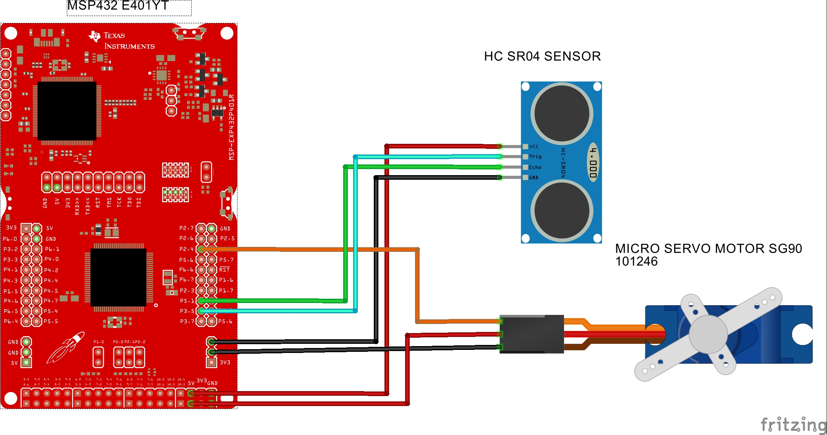

**COMMENTARY:**

* **Introduction**

This is a two-part lab which is aimed at enabling students gain a practical understanding of how ultrasound sensors interfaced with a micro servo motor (SG90) and microcontroller board (MSP432) work together to enable TI RSLK bot to drive through a course after it has identified its location.

* **Materials Required**
  + MSP432
  + TI-RSLK
  + HC-SR04 UltraSound Sensor
  + Micro Servo Motor SG90
  + F-M and F-F Jumper Wires
  + Energia 1.8.11E23
* **Theory**

The HC-SR04 works by sending an ultrasonic pulse and then sensing it as it returns. A microcontroller () and the use of the pulse In function is used to measure the time the pulse took to travel out, reflect off an object, and return. Knowing the speed of sound, the distance to the object can be calculated.

The servo motor uses an open loop control system to control its motion and direction. It’s an open loop electro-mechanical system.

The code integrates others used in Lab 3, 4, 5, 7 and parts of 6. The robot is to drive through a hallway. It should first localise it’s position then drive to a known point ‘x’, while driving straight.

* **Results**

Learned to program the robot to localise it’s position and then drive to a known location and stop. Lab 8 was completed with one main issue being the inability for the robot to drive through the room and avoid obstacles within a minute.